**Anekant Education Society’s**

**Tuljaram Chaturchand College of Arts, Science and Commerce, Baramati**

**Department of Statistics**

**Year – 2019-20**

|  |  |  |  |  |  |  |  |
| --- | --- | --- | --- | --- | --- | --- | --- |
| **Sr. No.** | **Name of Activity** | **Dates** | **Venue** | **No. of Student Beneficiaries** | **No. of Faculty Participated** | **Name of Resource Person** | **Expenditure** |
| 1 | Two Days Workshop on "Statistics in Medicine | 18th and 19th January 2020 | Prashsan Bhavan | 120 | - | Mr. Ajay Phatak  Mr. Karamchand Patil  Mrs. Jayshree Ganjwale | 55,500/- |
| 2 | Two Days Workshop on "Big Data Analytics” | 21st and 22nd January 2020 | Prashsan Bhavan | 120 | - | Mr. M. S. Kasture  Dr. A. J. Shivgaje | 15,000/- |
| 3 | Hands on Training on NLP and Image Processing Using R Software | 13th and 14th February 2020 | Department of Statistic | 60 | - | Dr. Sachin Adnaik | 10,000/- |
| 4 | Study Tour | 17th February to 19th February 2020 | Dapoli Krishiviyapeeth at Kokan  and  Rashtriya Chemicals & Fertilizers Limited (RCF) | 35 | 3 | - |  |

**Year – 2020-21**

|  |  |  |  |  |  |  |  |
| --- | --- | --- | --- | --- | --- | --- | --- |
| **Sr. No.** | **Name of Activity** | **Dates** | **Venue** | **No. of Student Beneficiaries** | **No. of Faculty Participated** | **Name of Resource Person** | **Expenditure** |
| 1 | Three Days National Webinar on "Predictive Analytics" | 11th, 12th and 13th February 2021 | Online  Youtube Live | 605 | 11 | Dr. D.N.Kashid  Prof. Dr. S.D.Gore  Dr. Akanksha Kashikar  Dr. T. V. Ramnathan  Prof. Madhukar Kasture  Dr. H.V.Kulkarni  Dr. Vijay Shivgotra  Prof. Dr. A.P.Gore | 33,500/- |

**Year – 2021-22**

|  |  |  |  |  |  |  |  |
| --- | --- | --- | --- | --- | --- | --- | --- |
| **Sr. No.** | **Name of Activity** | **Dates** | **Venue** | **No. of Student Beneficiaries** | **No. of Faculty Participated** | **Name of Resource Person** | **Expenditure** |
| 1 | Webinar on National Statistics Day 2021  “Remembering Prof. P. C. Mahalanobis, the Father Indian Statistics | 29 June 2021 | Department of Statistics, T. C. College of Arts, Science and Commerce, Baramati | 130 | 11 | Mr. Saurabh Kadam  Prof. Dr. S. D. Gore | 3000/- |
| 2 | Five Days Workshop on Machine Learning Using Python | 10th January, to 14th January, 2022 | Collaboration with AIS Solutions Pvt. Ltd., Pune, Department of Statistics and RUSA | 47 | 02 | Mr. Prajyot Patil (Founder and CEO of AIS Solutions Pvt. Ltd., Pune) | 78,700/- |
| 3 | Six Days Training Program on Classification and Regression Techniques | 21th February, to 26th February, 2022 | Department of Statistics Tuljaram Chaturchand College of Arts, Science and Com. Baramati and RUSA (under ED- Cell) | 47 | 12 | Dr. D. N. Kashid  (Former Head, Department of Statistics, Shivaji University, Kolhapur) | 25,500/- |
| 4 | Study Tour | 12th to 14nd March 2022 | Dapoli Krishiviyapeeth at Kokan  and  Rashtriya Chemicals & Fertilizers Limited (RCF) | 38 | 3 | - |  |
| 5 | Hands on Training Program Tableau Software | 19th to 22nd March 2022 | Department of Statistics Tuljaram Chaturchand College of Arts, Science and Commerce, Baramati and RUSA (under ED- Cell) | 46 | 02 | Mr. Shard Arun Kolse (Data Science Analyst, Accenture, Banglore) | 9,500/- |
| 6 | Two Days Workshop on Applied Multivariate Analysis | 27th March, to 28th March, 2022 | Department of Statistics T. C. College of Arts, Science and Commerce, Baramati and RUSA | 53 | 03 | Prof. Sharad D. Gore (Former Head of Department of Statistics, SPPU, Pune) | 10,500/- |
| 7 | Eight Days Hands on Training Program MS – Excel For Commerce Students | 21th march to 29th march,2022 | Department of Statistics Tuljaram Chaturchand College of Arts, Science and Commerce Baramati and ED Cell | 35 | 02 | Mrs. Sunita Kalgaonkar (Modern Computer Education, Baramati.) | 19,000/- |
| 8 | Three Days National Webinar on "Medical Statistics" | 07th, 08th and 09th April 2022 | Department of Statistics, Tuljaram Chaturchand College of Arts, Science and Commerce, Baramati (Autonomous) | 458 | 13 | Prof. Dr. Anil Gore, Dr. S. A. Paranjape, Dr. Sharvari Shukala, Mr. Aniruddha Deshmukh, Mr. Samadhan Ghubade, Mr. Manoj C Patil, Dr. Mohan Kale, Mr. Chaitanya Shinde and Mrs. Manjushree Birajdar | 21,500/- |
| 9 | Inauguration of Prof. Sharad Gore Laboratory at Department of Statistics | 09th April 2022 | Department of Statistics, Tuljaram Chaturchand College of Arts, Science and Commerce, Baramati (Autonomous) | - | - | Dr. Rajendra Gurao, Dr. Haribhau Bhapkar, Mr. Saurabh Kadam, Dr. Jaya Limbore |  |

**Year – 2022-23**

|  |  |  |  |  |  |  |  |
| --- | --- | --- | --- | --- | --- | --- | --- |
| **Sr. No.** | **Name of Activity** | **Dates** | **Venue** | **No. of Student Beneficiaries** | **No. of Faculty Participated** | **Name of Resource Person** | **Expenditure** |
| 1 | Webinar on National Statistics Day 2022 | 29 June 2022 | Google Meet | 45 | 13 | Dr. Amita Dharmadhikari and  Dr. Vidhya Prayag,  Retired Professors,  Modern College, Pune |  |
| 2 | Ten Days Hands on Training Program MS – Excel For Commerce Students | 25th July to 12thAugust, 2022 | Department of Statistics T. C. College Baramati | 53 | 04 | Mrs. Sunita Kalgaonkar (Modern Computer Education, Baramati.) | 23,000/- |
| 3 | Hands on Training on Data Visualization through Power BI | 12th to 14th August | Department of Statistics T. C. College Baramati | 48 | 04 | Mr. Hiren Kakkad CEO and Founder Stat Modeller | 39,472/- |
| 4 | Hands on Training Program on Tableau Software | 10th,11th ,17th and 18th September 2022 | Department of Statistics T. C. College Baramati | 96 | 05 | Mr. Shard Arun Kolse (Data Science Analyst, Accenture, Banglore) | 19,000/- |
| 5 | One Day Workshop on Official Statistics | 15th September 2022 | Seminar Hall T. C. College Baramati | 205 | 13 | Mr. Vaman B. Kale (Director of Economics & Statistics, Government of Maharashtra, India) | 10,000/- |
| 6 | Hands on Training Program on Classification and Regression Techniques | 19th to 24th September 2022. | Department of Statistics T. C. College Baramati | 46 | 05 | Dr. D. N. Kashid Sir (Former Head, Department of statistics, Shivaji Univaersity) and  Ms. Zanjurne Pooja Shivaji (Assistant Professor, T. C. College, Baramati) | 31,000/- |
| 7 | Six Days Hands on Training program on Machine Learning Using Python | 5th December to 10th December, 2022 | Department of Statistics T. C. College Baramati | 53 | 04 | Mr. Prajyot Patil (Founder and CEO AIS Solutions Pvt. Lts., Pune) | 57,000/- |
| 8 | Two Days Workshop on Internet Awareness for Commerce Students | 09th to 10th January, 2023 | Department of Statistics T. C. College Baramati | 35 | 02 | Prof. Rahul Shah (Department of Computer Science, T. C. College, Baramati) | 7,000/- |
| 9 | Three Days Hands on Training on Data Processing Using SQL | 19th to 21st January, 2023 | Department of Statistics T. C. College Baramati | 48 | 06 | Mr. Mehul Gandhi, Stats Modeller, Vadodara, Gujrat | 36,689/- |
| 10 | Workshop on "Statistical Software used in Biostatistics" | 23rd, 24th, 25th and 27th March, 2023 | Department of Statistics T. C. College Baramati | 45 | -- | Prof. V. C. Kakade  Dr. N. K. Dhane  Dr. V. V. Patil  Mr. C. P. Swami  Mrs. P. M. Mohite  Mrs. S. D. Wadkar  Ms. N. A. Jagtap  Miss. K. C. Kale  Ms. A. G. Deshmukh  Miss. R. N. Rakate  Ms. S. B. Choudhar  Department of Statistics  T. C. College, Baramati | 26,300/- |
| 11 | One Day International Workshop on High – Dimensional Data and AI/ML Algorithms with Applications | 27th March, 2023 | Department of Statistics, SPPU, Pune | 10 | 05 | Dr. Madhuri Kulkarni (SPPU, Pune)  Prof. Sushma Bendre, (ISI Chennai)  Dr. Akanksh Kashikar (SPPU, Pune)  Prof. T. V. Ramanathan (SPPU, Pune)  Prof. Vijay Nair (University of Michigan) | 13,210/- |

**IQAC Youth Festival 2022 – 23**

**Date: 23rd and 24th January, 2023**

Tuljaram Chaturchand College of Arts, Science and Commerce, Baramati and IQAC organized Three Days IQAC Youth Festival 23rd January to 25th January, 2023. In this festival Department of Statistics organized two activities namely, Kaun Banega Statistician and Poster Presentation Competition for the Statistics Students. The details are as follows:

|  |  |  |  |
| --- | --- | --- | --- |
| **Name of the Activity** | **Date** | **No. of Participants** | **Winners** |
| Poster Presentation Competition | 23/01/2023 | 22 | First Prize: Rutuja Jagdale and Priti Survase (FYBSc)  Second Prize: Dnyaneshwari Phadatare (SYBSc)  Third prize: Bharat Jambhulkar and Mane Prapti (TYBSc) |
| Kaun Banega Statistician (T.Y.B.Com.) | 24/01/2023 | 04 | First Prize: Ashwini Jaykar (TYBCom) |
| Kaun Banega Statistician  (B.Sc.) | 24/01/2023 | 16 | First Prize: Vaishnavi Chavan (FYBSc)  Second Prize: Neha Oval (SYBSc)  Third prize: Aditya Magar (TYBSc) |

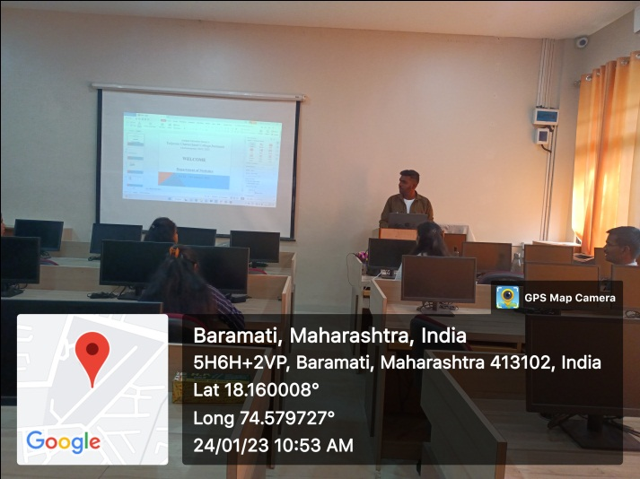 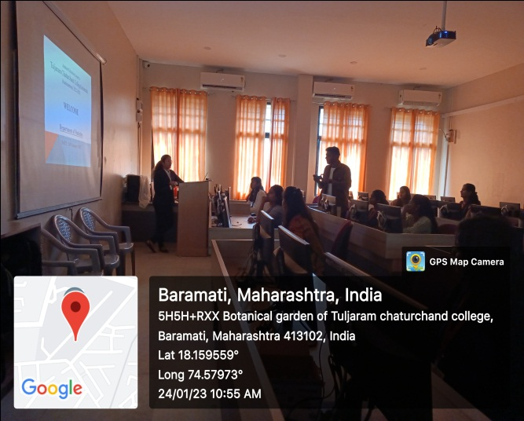

**National Science Day (2022 – 23)**

**Date: 28th February, 2023**

Tuljaram Chaturchand College of Arts, Science and Commerce, Baramati and Science Forum Committee celebrated National Science Day on 28rd February, 2023. On this occasion, Department of Statistics organized two activities namely, Statistics Quiz and Poster Presentation for the Statistics Students. In which 25 students participated in poster presentation and 15 students were participated in Statistics Quiz.:

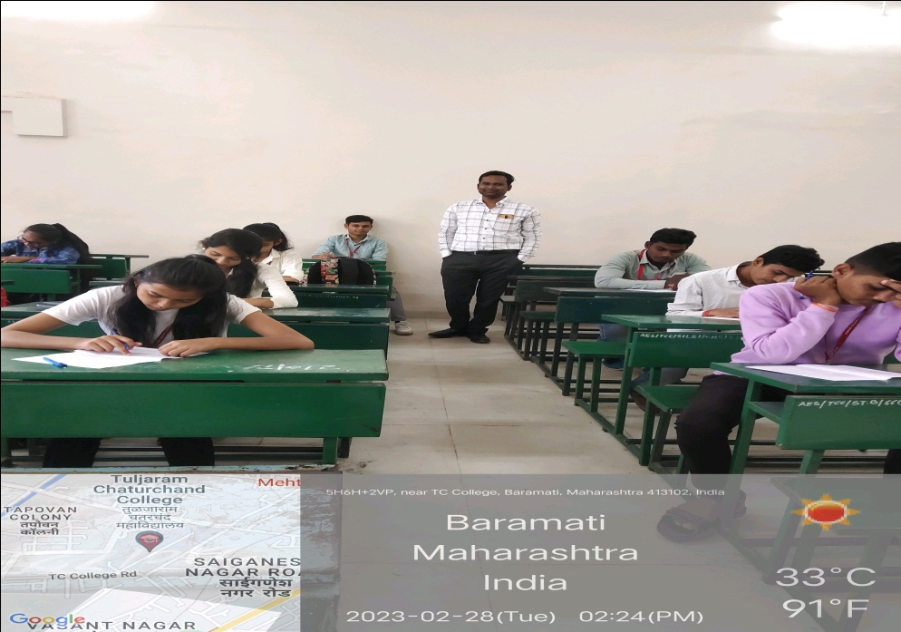

**Year – 2023-24**

|  |  |  |  |  |  |  |  |
| --- | --- | --- | --- | --- | --- | --- | --- |
| **Sr. No.** | **Name of Activity** | **Dates** | **Venue** | **No. of Student Beneficiaries** | **No. of Faculty Participated** | **Name of Resource Person** | **Amount** |
| 1 | Celebration of National Statistics Day 29th June 2023 | 03 July 2023 | Google Meet | 86 | 13 | Dr. Rahul Jagtap Deputy Director General Government of India, Ahmedabad Gujrat | 2000/- |
| 2 | Ten Days Hands on Training Program MS – Excel For Commerce Students | 4st September 2023 to 14th September 2023 | Department of Statistics T. C. College Baramati | 11 | 04 | Miss Priya N. Rakate and Ms. Shital B. Choudhar  Department of Statistics T. C. College Baramati | -- |
| 3 | Hands on Training Program on Tableau Software | 8th,9th ,11th and 12th September 2023 | Department of Statistics T. C. College Baramati | 48 | 04 | Mr. Mehul Gandhi (Stat Modeller, Vadodara, Gujarat) | 8500/- |
| 4 | Statistics Awareness Program for 12th Science Students of T. C. College | 05th January, 2024 | Department of Statistics T. C. College Baramati | 161 | 03 | Dr. Neeta Dhane, Dr. Vaishali Patil and Mr. Chandrasheklhar Swami  Department of Statistics T. C. College Baramati |  |
| 5 | Study Visit at Department of Statistics, SPPU, Pune | 14th Feb, 2024 | Department of Statistics, SPPU, Pune | 43 | 03 | Dr. Akanksha Kashikar  Department of Statistics, SPPU, Pune | 2000/- |
| 6 | M. Sc. Part II Statistics Study Tour | 19th February to 21st February 2024 | Dr. Balasaheb Savant Krushi Vidyapith, Dapoli | 31 | 03 | Dr. Vaibhav Rajemahadik  Dr. Balasaheb Savant Krushi Vidyapith, Dapoli |  |
| 7 | One Day Workshop on Skill Enhancement in Statistical Techniques | 23th March 2024 | Department of Statistics T. C. College Baramati | 68 | 04 | Mr. Prajyot Patil, AIS Solutions Pvt. Ltd. Pune, (Founder and CEO) | 2500/- |
| 8 | Two Days Hands on Training on Creation of Dashboard in MS- Excel | 27th March & 28th March 2024, | Department of Statistics T. C. College Baramati | 89 | 10 | Mr. Hiren Kakkad (CEO, Stat Modeller, Vadodara Gujarat) | 15000/- |

**Year – 2024-25**

|  |  |  |  |  |  |  |  |
| --- | --- | --- | --- | --- | --- | --- | --- |
| **Sr. No.** | **Name of Activity** | **Dates** | **Venue** | **No. of Student Beneficiaries** | **No. of Faculty Participated** | **Name of Resource Person** | **Amount** |
|  | Celebration of National Statistics Day 29th June 2023 | 13th July 2024 | Seminar Hall Prerana Bhavan | 86 | 13 | Mr. Mukunda Dhale, Statistical officer at the Department of Statistics and Information Management, Reserve Bank of India. | 1000/- |
|  | Yoga for Enhancing Memory Power and Concentration | 12st August, 2024 | Jivraj, T. C. College Baramati | 79 | 15 | Dr. Nilesh Mahajan,  Principal Yoga Mahavidyalay,  Baramati | 2000/- |
|  | Opening Ceremony of M. Sc. Data Science Course | 21st August, 2024 | Seminar Hall  Prashsan Bhavan | 107 | 13 | Dr. S. R. Kulkarni, former professor of Statistics at Shivaji University, Kolhapur. | 5500/- |
|  | One Day Workshop on Clinical Trials | 29th August 2024 | Seminar Hall  Prashsan Bhavan | 90 | 15 | Mr. Ajinkya Date  CEO  SRE Statconsultancy Services Private Limited,  Khalapur, Raigarh | 14000/- |
|  | One day workshop on "Actuarial Statistics” | 13th September 2024 | Jivraj, T. C. College Baramati | 155 | 16 | Mr. Mohit Gupta, Manager, Institute of Actuaries of India | -- |
|  | One Day Workshop on Introduction to Latex | 17th Oct 2024 to 24th Oct 2024 | Department of Statistics T. C. College Baramati | 40 | 2 | Dr. Shaila Jadhav, Department of Mathematics, T. C. College Baramati | 5000/- |
|  | Opportunities to graduate students at abroad | 27th December, 2024 | Department of Statistics T. C. College Baramati | 30 | 03 | Mr. Rohan Jagtap,  Jermani | -- |
|  |  | 30th December, 2024 | Department of Statistics T. C. College Baramati | 30 | 02 | Ms. Trupti Ghadge, | -- |
|  | Case Studies in Statistics | 18th January 2025 | Department of Statistics T. C. College Baramati | 75 | 13 | Dr. Akanksha Kashikar, Department of Statistics, SPPU, Pune | 1500/- |
|  | Why Statistics | 18th January 2025 | Department of Statistics T. C. College Baramati | 63 | 13 | Dr. Akanksha Kashikar, Department of Statistics, SPPU, Pune | 1500/- |
|  | Hands-On Training Program on Data Visualization through Power BI | 16th to 20th January 2025 | Department of Statistics T. C. College Baramati | 44 | 5 | Mr. Mehul Gadhi, Stat Modeller, Vadodara, Gujrat | 21240/- |
|  | Profession Resume Building Workshop | 31st January, 2025 | Department of Statistics T. C. College Baramati |  | 03 | Dr. Smita Khatri,  Anekant Institute of Management Studies, Baramati | 1500/- |